Central Tendency and Variability

Central Tendency is a fancy term we use to describe Mean, Median, and Mode.

Mean – average
(good to use in data sets without extreme highs and lows)

Median – middle number when in order from least to greatest
(good to use instead of mean when there are extreme values, aka outliers)

Mode – number that occurs the most often

** When the mean and median values are close to each other, the data set or information is considered “good data”/”more reliable”. **

Variability is a term we use to describe the spread of a data set. The most common used measures of variation are range, interquartile range, variance, and standard deviation. Today we’re only going to mess with range and interquartile range.

Box-and-Whisker Plots

A box-and-whisker plot is a good tool to use to show variability because it shows the spread of a data set. A box and whisker plot displays 5 key points.

- Minimum Value
- Maximum Values
- The Median
- 1st Quartile (the median of the lower half of the data)
- 3rd Quartile (the median of the upper half of the data)

Range is the value we get when we subtract the minimum value from the maximum value. (Maximum – Minimum)

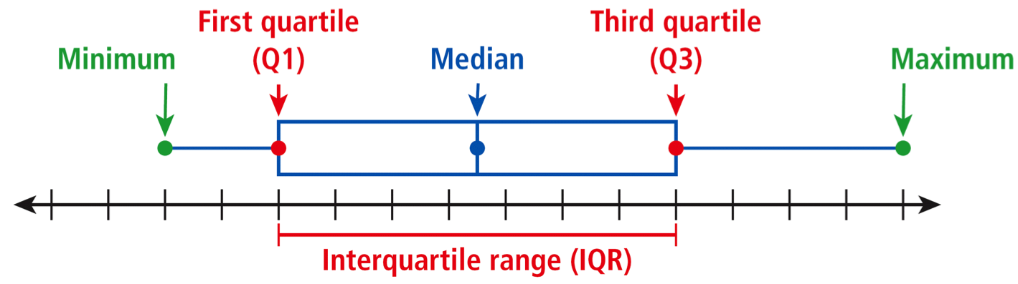
The Interquartile Range (IQR) is the difference between the 1st and 3rd quartiles. (Q3 – Q1) It represents the middle 50% of the data.

Assignment: pg 833 # 2-4, 6-8, 13-15, 17-19

