**Independent and Dependent Events**

**Independent Events**

Events are **independent** if the occurrence of one event does not affect the probability of the other.

For example, if we toss a coin twice, having it land heads up on first toss and landing heads up on the second toss are independent events. The outcome of one toss does not affect the probability of heads on the second toss.

To find the probability of tossing heads twice, multiply the two individual probabilities together. (½ **•** ½ = )

**\*\* If A and B are independent events, then P(A and B) = P(A) • P(B) \*\***

***Example #1***

Find the probability of rolling a 4 on one number dice and an even number on another dice.



Take the probability of the first event and multiply

it by the probability of the second event.

***Practice Problem #1***

Find the probability of tossing a coin and having it land heads 4 times in a row.

**Dependent Events**

Events are **dependent** if the occurrence of one event affects the probability of the other.

For example, say we have a bag with 2 apples and 1 orange. If you pull out 2 pieces of fruit, the probabilities will change *depending* on the outcome of the first pull.

Before I pull a piece of fruit I have a  probability of picking an apple and a  probability of picking an orange.

Let’s say I pull an apple first. For my **next** pull, I have both a ½ probability of picking an apple and a ½ probability of picking an orange.

This would have changed if I had pulled an orange from the bag first. If this has been the case, then on my second pull there would have been a 100% chance of grabbing an apple and a 0% chance of grabbing an orange.

**\*\* If A and B are dependent events, then P(A and B) = P(A) • P(B | A), where P(B | A) is the probability of B, given that A has occurred. \*\***

***Example #1***

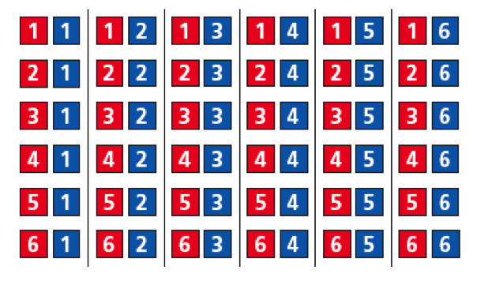

Two numbered dice are rolled, one red die and one blue die. Find the probability that the red die shows a 1, and the sum is less than 4.

These events are dependent because the probability that the sum is less than 4 ***depends*** on whether or not the red die shows a 1 first.

P(red 1) =  *(Of 36 outcomes, 6 of them have a red 1)*

P(sum < 4 | red 1) =  *(Of 6 outcomes with red 1, only 2 have a sum less than 4)*

***Practice Problem #1***

Two cards are drawn from a deck of 52. Find the probability of selecting a face card and then selecting a 7, when the first card is not replaced.

First, find the probability of selecting a face card.

Then, find the probability of selecting a 7. (Remember there is one less card because we do not replace the first one.)

Now multiply these two probabilities together to get our final answer.

Come show me your answer so I know you’re on the right track!

**Assignment: Practice B Worksheet + pg 815** **#2-4, 8-14, 17-18**