Inverse Functions

There are a few different ways we can find the inverses of functions.

1. Graphically

The inverse of a function is found in a graph by reflecting the function over the line y=x.
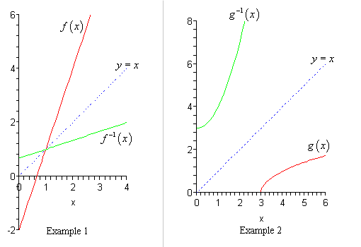

Notice in each example how the original function is reflected over the line y=x.

2. Table of Values

To find the inverse function if you’re given a table, all you have to do is switch the x and y coordinates.

Example:

Original Inverse
x | y
0 | 3
1 | 5
2 | 7
x | y
3 | 0
5 | 1
7 | 2

3. Equation

To find the inverse of an equation you first switch the x and y variables. Then solve the new equation for y.

Example: y = 2x + 3

Switch the variables x and y and then solve for y. Show your work below.

Do Homework: WS + pg 501 #2-17

