**Parallel and Perpendicular Lines**

Parallel Lines:

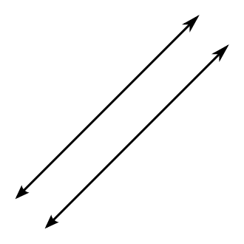Parallel lines are lines that will never touch. Therefore because they will never touch, they also do not have any points in common.

What’s important for you to know about parallel lines has to do with the slope. If you think about it, the two lines, in order to be parallel, both have to rise and run the same amount. Therefore, parallel lines will have the **same** slope.

(Examples: y = 3x + 1 and y = 3x + 5  and )

Perpendicular Lines:

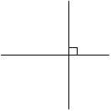Perpendicular lines will touch. In fact they will always touch in a right angle. But what will happen with the slope?

When you multiply the two slopes together it will equal -1. Let’s look at an example to clear this up.

Example:  and 

What is the slope of the first line? _______ What is the slope of the second line? _______

Now multiply these two numbers together. What do you get? _________

Because you got -1, it means that these two lines are perpendicular.

Now what if you were given one slope, for example . How would you find the slope of the second line? To do this you have to take the negative reciprocal of the first slope.

What is the reciprocal of ? _______ Now put a negative in front of this. ________

That will be the slope of the line that is perpendicular to the first line.

To check this multiply the two slopes together. If you get -1 you’ve done it correctly.

The main type of problem you’ll get is you’ll be given an equation and a coordinate point and be asked to find a second equation that is either parallel or perpendicular to the first. Let’s look at one.

Example: Write an equation in slope-intercept form for the line that is parallel to the line y = 3x – 7 and that passes through the point (0, 4).

Since we want a line parallel to the given line, what will the slope be? ____________

Write the slope-intercept formula below. Plug in the slope as well as the x and y values from the coordinate point. When you are done solve for the y-intercept.

Now that you’ve got the new y-intercept, write down the new equation in slope-intercept form. Come show your answer to me.

*Do Homework:* pg 354 #22-44 even