**Theoretical and Experimental Probability**

**Probability** is the measure of how likely an event is to occur. Each possible result of an experiment or situation is called an **outcome**. The **sample space** is the set of all possible outcomes.

Probabilities are written as fractions or decimals from 0 to 1, or as percents from 0% to 100%.

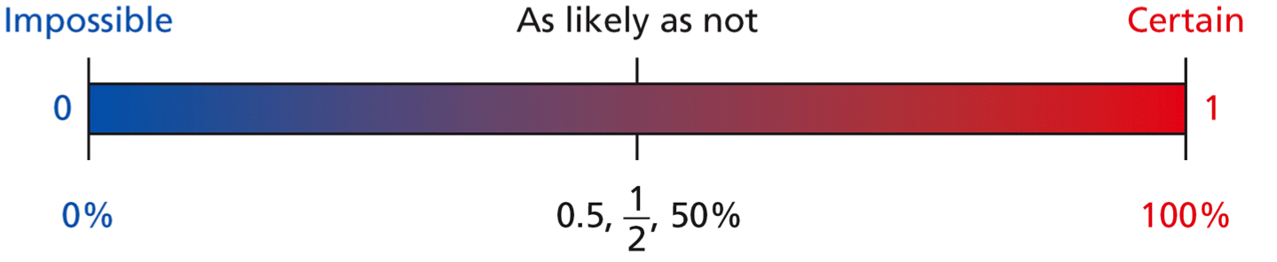

**Theoretical Probability**



***Example #1***

A CD has 5 rap songs and 7 country songs. What is the probability that a randomly selected song is a rap song?



Now let’s look at a probability problem that uses Permutations/Combinations.

***Example #2***

Each student received a 4-digit code to use the library computers, with no digit repeated. Manu received the code 7654. What was the probability that he would receive a code of consecutive numbers?

Step 1: Does this problem use Permutations or Combinations?

Does the order of the numbers matter? Yes or No? _________________

Step 2: Since order is important we will use Permutations.

There are 10 different digits and we are picking 4 of them. Let’s find out what our total sample space will be.

 → → 10 * 9 * 8 * 7 = _______________

Step 3: Find the number of favorable outcomes.

The favorable outcomes would be 0123, 1234, 2345, 3456, 4567, 5678, 6789, and the reverse order of each of those. That is a total of 14 favorable outcomes.

Step 4: Find the probability.

P(consecutive numbers) =  = 

**Experimental Probability**

experimental probability = 

We often use experimental probability to estimate theoretical probability and to make predictions about real world events.

***Example #1***

The table below shows the results of choosing one card from a deck of cards, recording the suit, and then replacing the card.

|  |  |  |  |  |
| --- | --- | --- | --- | --- |
| Card Suit | Hearts | Diamonds | Clubs | Spades |
| Number | 5 | 9 | 7 | 5 |

Find the experimental probability of choosing a diamond. _________________

Find the experimental probability of choosing a card that is not a club. _______________

You should now be able to do the following things:

* I can distinguish between theoretical and experimental probability.
* I can find theoretical and experimental probabilities.
* I can define and interpret commonly used expressions of probability.
* I can understand and construct sample spaces.

**Assignment: Practice B Worksheet + Practice C Worksheet**