Linear Functions

Graphing:

When you hear the word linear you think of what word? ______________________________. Right a line! So when we graph these linear functions, they will always be a line.

Tables:

Alright, so that takes care of recognizing linear functions from a graph, let’s talk about identifying them from a table now. Look at the following table.

x | y
-2 | 4
-1 | 7
0 | 10
1 | 13
2 | 16
Step 1: Look at the x-values. Do they form a pattern or are they in order? _______________

Step 2: Look at the y-values. See if there is a constant difference between the values. What is the difference between the y-values? __________________

* The same amount should be added or subtracted each time! * And in this case the y-value went up by 3 each time.

Equations:

The equations of linear functions will look very familiar. When you look at a linear function the x and y variables are to the 1st power. (Ex. y = 3x – 4, 2x + 6y = 12) There must also be no variables in the denominator!

Summarize: I just showed you 3 different ways to identify linear equations, graphing, tables, and equations. I want you to summarize what I just said about each one below in your own words. Write something you’ll remember.

Graphs: _______________________________________________________________________________________

Tables: _______________________________________________________________________________________

Equations: ___________________________________________________________________________________

Standard Form: Ax + By = C

This is the standard form for linear equations. Something important to know about standard form is that the x and y variables are on one side of the equation. If you get a problem where they are not on the same side you’re going to have to move them to the same side before you continue.

One question you might get asked is to graph an equation that is in standard form. Now you already know how to make a table of values and graph it using points you choose, BUT I’m going to show you how to graph one using intercepts.

Example: 2x + 6y = 12

Before we begin, is this a linear function? __________ Is it in standard form? ___________

Make sure you’ve said “Yes” to both before you move on.

Now to graph using intercepts we first have to understand what intercepts are.

* An intercept is where a function line crosses one of the coordinate axes (x-axis or y-axis). *

Ready for some critical thinking? When a function line crosses the y-axis, what is the x-value? _____________

And when a function line crosses the x-axis what is the y-value? ____________________

(You should have put zero for both of those values. If you didn’t, either re-think for a second or come ask me for help!)

So go back to our example problem. If we want to find the y-intercept we need to plug in 0 for x. This would make our equation look like this then: 6y = 12.

If you solve that for y, what do you get? _________________ This is the y-intercept.

And if we want to find the x-intercept we need to plug in 0 for y. Why? Because when the function line crosses the x-axis, the y-value is 0.

If you plug in 0 for y and solve for x, what do you get? ___________ This is the x-intercept.
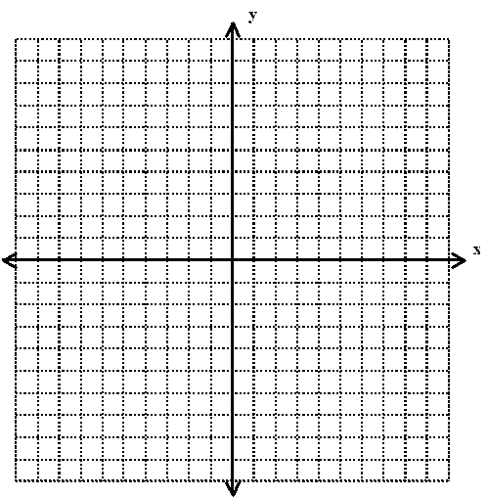

Since the y-intercept was 2, put a point at y=2 and since the x-intercept was 6, put a point at x=6. Now connect these two points to form a line (a linear function).

Congratulations, you just graphed a linear function using intercepts! You are awesome!

Do Problems: pg 300 #5-12, #15-24, #31-41 odd

