Relations and Functions

This unit will be on relations and functions. No I’m not talking about the relations of people in the hallway, I’m talking about ordered pairs on a graph. So if you see the word relationship throughout this unit, just remember it is talking about (x,y) pairs.

Now functions are pretty simple as well. A function is a relationship (remember what that means) where each x value is paired with exactly one y value.

Write that down so you remember:

A function is _________________________________________________________________________________.

Before we get into talking about functions, it’s important to mention domain and range. These are two terms that you definitely need to know!

Domain- The domain is all the x-coordinates of a given set of ordered pairs.
Range- The range is all the y-coordinates of a given set of ordered pairs.

So for example if I gave you the following ordered pairs: (1,3), (2,4), and (3,5), what would the domain and range look like?

Domain = __________________ and Range = __________________

Did you say 1, 2, 3 for domain and 3, 4, 5 for range? Good! If not, raise your hand!

Now let’s get back to functions. There are lots of different ways to tell if a relationship is a function. Let’s look at a few of them.

What’s the definition of a function again?

A function is _________________________________________________________________________________.

1. Mapping Diagram

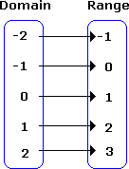
As you can see, we put all the domain values (x-coordinates) in one diagram and all the range values (y-coordinates) in another one. We then draw arrows that match up which x-coordinates go with which y-coordinates.

Is this relationship a function? (Look back at your definition if you need help. _______________

Let’s look at these next two mapping diagrams. Tell me whether each on is a function or not. Write Yes or No next to each one.
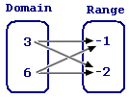
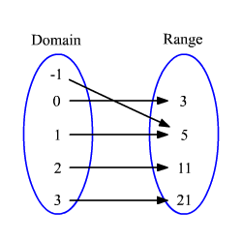

Answers: The first mapping diagram should be a NO and the second one should be a YES. If you are confused as to why, look at the definition of a function and then check out the explanations below.

Explanations: The first mapping diagram is NOT a function because both the 3 and the 6 go to two different y-values. Let me repeat that. The same x-value went to two different y-values. The second mapping diagram IS a function. Why? Because there is not one x-value that goes to two different y-values. Every x-value goes with exactly one y-value.

If this still seems confusing at this point, raise your hand and I will help you understand the difference.

2. Table

Another way coordinate points will be presented to you is in a table. It’s very similar to the mapping diagram but without the arrows drawn for you.

As before tell me whether each table represents a function or not. Write YES or NO next to the side of each table.

x | y
-1 | 1
0 | 0
1 | 1
2 | 4
x | y
2 | 3
0 | -2
1 | 1
2 | 4

Answers: The first table is YES and the second table is NO. If you didn’t get that and are stuck, get some help from a neighbor or raise your hand.

3. Graphing

The third way to tell whether a relationship is a function is by graphing the points and using what is called the Vertical Line Test.

When you have graphed all your points take your pencil (this will act as your vertical line) and move it left to right across your graph.

IF your pencil ever touches two parts of the line at the same time, the relationship is NOT a function. However IF your pencil only ever touches the line once, it IS a function.

Look at these two graphs. Use your pencil and do the Vertical Line Test to see whether or not the line is a function. When you have decided, check the caption of the picture for your answers.
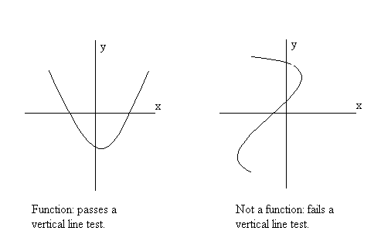

Those are the three main ways we decide if relationships are functions.

Do Problems: pg 239 #3-14

Function Notation

Look at the following function:

All the f(x) part means is that we have a function “f” where the variable in the function is x. So if we had g(n) it would be a function “g” where the variable was what? __________

Now look back up at that function. What if I asked you to evaluate the function for f(2). What would that mean? What would that look like?

Well notice that the 2 took the spot where the x used to be. We are going to do the same thing in the equation. Everywhere there was an x, we are now going to substitute in the value 2. So when you see f(2), that means evaluate the function “f” for the value of x=2.

Go ahead and solve that below. Plug in 2 for the x and come up with an answer.

You should get that f(2) = 10. If not raise your hand and get some help.
Try these next two examples. If you get these two right you’re ready to go on to the assignment.

Evaluate each function2 for the given input values.

- For g(x) = 2.5x + 4, find g(2) and g(6).

- For h(t) = t² – 6, find h(4) and h(-3).

Do Problems: pg 249 #9-11 and #20-22

