**Slope**

What kind of real life things do you think of when you hear the word “slope”?

Since we just dealt with linear functions yesterday, it should come as no surprise that when we talk about slope, we are typically talking about the slope of a *line*.

The best way to remember what slope is, is to remember it as the steepness of a line.

How do we find slope? How do we calculate the numerical value of slope?

 What does this mean?

To understand this, we have to know what rise and run mean. Think about these words in real life. When you rise you go up. So therefore in math and with slope rise will correspond to the y-axis and more specifically the change in the y-axis. Run would then of course correspond to the change in the x-axis.

What is rise? ______________________________________________

What is run? ______________________________________________

Here is the mathematical formula: 

Notice the rise part was replaced with y’s and the run part was replaced with x’s?

Practice Problem #1

Find the slope between the points (-2,-3) and (4,1).

To start this problem I like to identify in my coordinate points which one is the x and which one is the y. Since we have two points label the first one x1 and y1 and the second point with x2 and y2.

Now that you’ve got them labeled, plugging them in and finding the slope shouldn’t be any trouble. Show your work below.

You should get that the slope is  which reduces down to .

This means that the slope of this line rises 2 and runs 3. Another way to think about it is that the change in the y-coordinate each time is 2 and the change in the x-coordinate each time is 3.

Practice Problem #2

Find the slope of the following line.

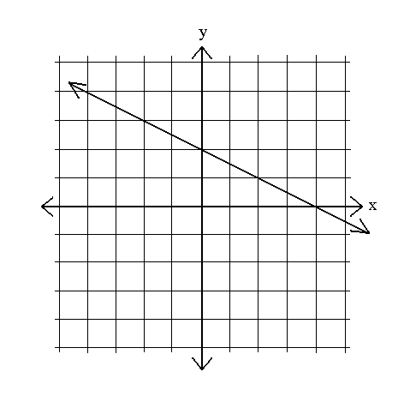

Unlike the first example you weren’t given specific points. So you can’t plug anything into the slope formula, *yet.* What you should try to do is find two points on the line. Then use those two points to find slope. Show your work below.

**Slope Intercept Form**

Yesterday we learned how to graph lines in standard form. We used intercepts and connected the two intercepts to make a line. Today we’re still going to be graphing linear functions, except instead of using Standard Form and intercepts; we’re going to use something called Slope Intercept Form.

Slope Intercept Form: **y = mx + b**

where *m = slope* and *b = y-intercept*

Example: y = 2x – 5

There are two ways to graph this equation. One way you already know is to pick x-values, plug them in, and then graph the coordinate points. (You’ve already done this way before.)

The easier way is what I’m about to show you.

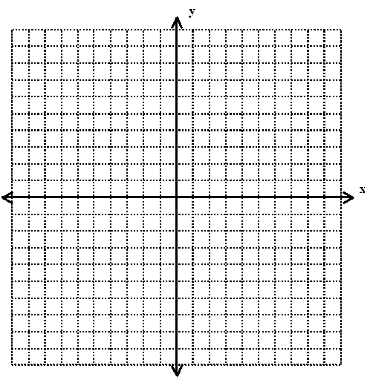

Look at the equation y = 2x – 5

What is the y-intercept? ____________

Go to the graph and put a dot at y = -5.

What is the slope? ____________

If you put this as  what would it look like? ____________

So now from the point y = -5, go up 2 and over 1 and make a dot. Go up 2 over 1 and make a dot. Connect your points to make your linear function.

Practice Problem: 



What is the y-intercept? ___________

What is the slope? ____________

Graph the linear function.

**Creating an Equation**

What if you were given a table or a graph and you had to create the equation? Could you go backwards from the stuff we’ve been doing above? Let’s see if you can.

Example:

|  |  |
| --- | --- |
| x | y |
| -2 | 8 |
| -1 | 6 |
| 0 | 4 |
| 1 | 2 |
| 2 | 0 |

Let’s start with the formula for slope intercept form: y = mx + b

We need to find two things, the slope and the y-intercept.

The y-intercept will be where x=0. (In other words the y-value when x=0.)

To find the slope you need to pick two coordinate points from the table. Then plug them in to the slope formula from above. () This will give you slope.

So what is the slope? _____________

What is the y-intercept? ______________

You should get that slope = -2 and y-intercept = 4. If not get some help!

What if you were given a graph instead?

Could you still find the slope and y-intercept? Of course you could!!



First thing you need to do is find the y-intercept. This will be the point on the graph where the function line crosses the y-axis.

What is the y-intercept? ____________

Aright, we have one point on our graph, (0,2). Let’s find another point so that we can count out slope.

I’m going to pick the point (4,0) because it crosses perfectly.

To get to (4,0) from (0,2) I have to go down 2 and over 4. So my rise over run would look like this: . Another thing you could do is take these two points and plug them into our formula for slope. Both ways will work!

So now go to our equation, y = mx + b and plug in the parts we know. (The slope and the y-intercept.) Write your answer below. Then come show it to me.

*Do Problems:* pg 323 #1-21