**Vertex of a Parabola**

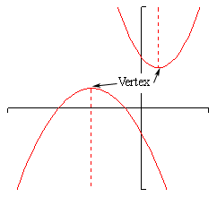Yesterday we talked about how to find the zeros and the axis of symmetry of a parabola. Today we are going to find the vertex of a parabola.

**Vertex –** the highest or lowest point on a parabola

* If a parabola opens upward, the vertex is the lowest point.
* If a parabola opens downward, the vertex is the highest point.

*Interesting Fact:* The x-coordinate of the vertex will always be the same as the axis of symmetry line. (See Picture)

**How to Find the Vertex**

***Step 1:*** To find the x-coordinate of the vertex, find the axis of symmetry by using zeros or the formula .

***Step 2:*** To find the corresponding y-coordinate, substitute the x-coordinate of the vertex into the function.

***Step 3:*** Write the vertex as an ordered pair.

**Example #1** Find the vertex of .

*Step 1:* Find the x-coordinate by first finding the axis of symmetry. ( Use  )

What is a? __________

What is b? ___________

*Step 2:* Plug in the x-value you just got into the equation and find y.

*Step 3:* Write your answer as a coordinate point. ____________________

Come show me your answer so I know you’re on the right track!

**Assignment: Practice B Worksheet + pg 604 #13-16 and #29-32**